MooMe IoT-AI Livestock Monitoring Platform

The proposed MooMe system is a smart livestock monitoring and automated control platform that uses Internet of Things (IoT) devices and artificial intelligence (AI) to improve dairy farming. The system continuously collects real-time data from each cow and the farm environment to help farmers make better decisions. It is designed not only to monitor cows but also to automatically respond to changes in their health and surroundings. This improves animal welfare, increases milk production, and reduces manual work on the farm.
Each cow is uniquely identified using RFID tags or smart collars, allowing the system to track individual health and productivity. Non-contact temperature sensors are installed above each cow’s position to monitor body temperature without disturbing the animal. In addition, environmental sensors such as temperature, humidity, and air quality sensors are installed inside the cowshed. These sensors help detect unhealthy conditions such as high heat or poor ventilation that may affect milk production.
When the system detects abnormal conditions, such as high body temperature, it automatically activates control mechanisms. These include water spraying systems and adjustable fans to cool the cow and maintain a comfortable environment. The system intelligently controls fan speed and water levels based on real-time conditions. This automated response helps prevent stress and disease, which are major causes of reduced milk production.
The system also includes an automated feeding and watering system. Each cow has its own feeding and drinking unit, and the amount of food and water is controlled based on the cow’s age and needs, which are set by the farmer through the dashboard. Sensors measure how much each cow eats and drinks per day, and this information is stored for analysis. This ensures that every cow receives the correct nutrition, which directly contributes to improved milk yield.
Milk production is monitored using smart milk meters that record the quantity of milk produced by each cow during milking. The system recommends the best milking times for each cow using AI analysis and notifies farmers through SMS and a dashboard. All data, including milk yield, feeding, and health status, is linked to the cow’s unique ID. The system also predicts future milk production and detects early signs of disease, allowing farmers to take action before problems become serious.
Farmers can access all information through a mobile or web-based dashboard, where they receive real-time updates, alerts, and recommendations. SMS notifications are sent using platforms like Mista.io while GSM will be used to ensure communication even without internet access. The system is powered by a solar backup to ensure continuous operation in areas without reliable electricity. Overall, the MooMe system provides a complete smart farming solution that combines monitoring, automation, and AI-driven decision-making to increase productivity and efficiency in dairy farming.
Block Diagram of system

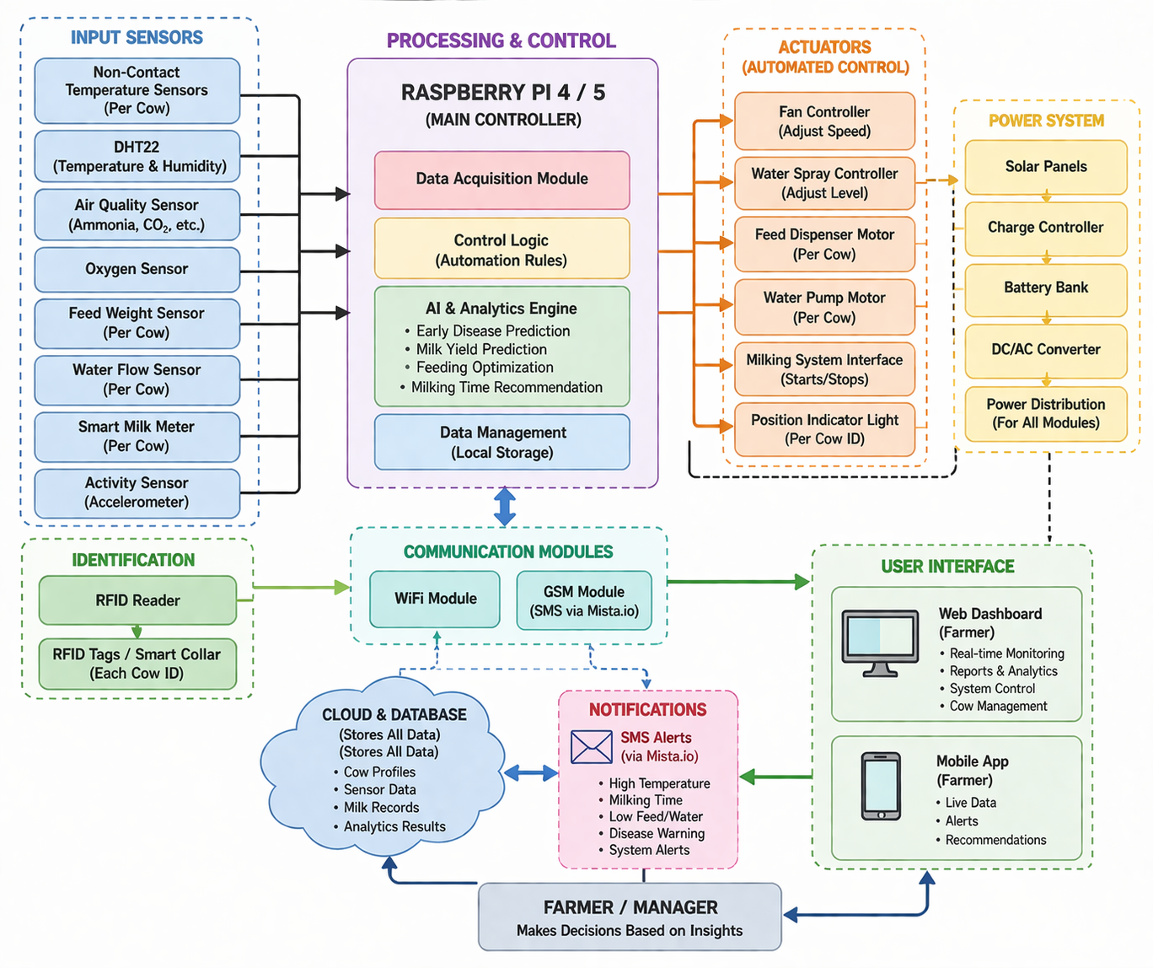

No | Component | Description | Quantity | Unit Price (RWF) | Total (RWF)
1 | Raspberry Pi 4/5 | Main controller | 1 | 120,000 | 120,000
2 | MicroSD Card (64GB) | Storage | 1 | 15,000 | 15,000
3 | Power Supply | Adapter | 1 | 10,000 | 10,000
4 | Non-contact Temp Sensor (IR) | Per cow | 12 | 20,000 | 240,000
5 | DHT22 Sensor | Environment monitoring | 2 | 8,000 | 16,000
6 | Air Quality Sensor (MQ-135) | Gas detection | 1 | 15,000 | 15,000
7 | Oxygen Sensor | Air monitoring | 1 | 25,000 | 25,000
8 | RFID Reader Module | Identification | 1 | 18,000 | 18,000
9 | RFID Tags | Per cow ID | 12 | 2,000 | 24,000
10 | Water Flow Sensor | Per cow intake | 12 | 10,000 | 120,000
11 | Load Cell + HX711 | Feed measurement | 12 | 15,000 | 180,000
12 | Smart Milk Meter | Milk measurement | 12 | 60,000 | 720,000
13 | DC Water Pump | Per cow | 12 | 20,000 | 240,000
14 | Fans (Cooling) | Shared system | 4 | 25,000 | 100,000
15 | Relay Modules | Control system | 5 | 8,000 | 40,000
16 | Motor (Feed Dispenser) | Per cow | 12 | 18,000 | 216,000
17 | Pipes & Spray Nozzles | Cooling system | 1 set | 60,000 | 60,000
18 | GSM Module (SIM800L) | SMS alerts | 1 | 15,000 | 15,000
19 | Wi-Fi Router | Connectivity | 1 | 35,000 | 35,000
20 | Solar Panel (200W) | Backup power | 1 | 150,000 | 150,000
21 | Battery (100Ah) | Energy storage | 1 | 180,000 | 180,000
22 | Charge Controller | Solar system | 1 | 40,000 | 40,000
23 | Inverter | Power conversion | 1 | 80,000 | 80,000
24 | Wires & Installation | Setup | 1 | 80,000 | 80,000
MooMe System – Cost Estimation (12 Cows)

The total cost for all components (12 cow’s system) is:

💰 Total = 2,699,000 RWF

Its estimation cost may increase or decrease

System Architecture


